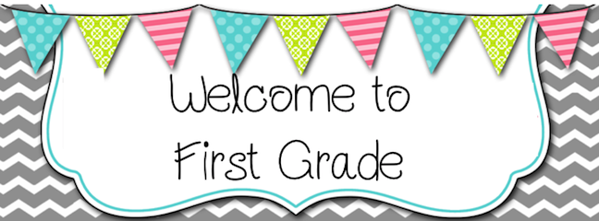
with Ms. Jennings, Mrs. Johnson, and Mrs. Schmutzler
kjennings-sas@eupschools.org
(906) 635-6629 ext. 5622
Dear first grade families,
Hello! I am Kathryn Jennings-Monck and I will be one of your child’s First Grade teachers this year. I retired in 2020 after 26 years of teaching, 23 of them with Sault Schools in First Grade, Kindergarten, and Reading Intervention. My last classroom was First Grade at Washington right across the hall from ours! I have come out of retirement to fill a vacancy until December. I will work alongside the new teacher for a smooth transition.
I live in Barbeau with my husband, Jeff. We have two grown children and one wonderful grandson with another due in February. I look forward to a fantastic school year!
We have a partner classroom! I will be team teaching with Mrs. Jamie Johnson and her student teacher, Mrs. Chloe Schmutzler. Mrs. Johnson and Mrs. Schmutzler will be teaching Science to both classes and I will be teaching Social Studies. We will combine classes for other subjects and special events.
Here is some information on our classroom procedures. Please review and contact me with any questions or concerns.

ATTENDANCE
Students are required to be at school by 9:00 A.M. or they will be counted as tardy. For safety reasons, parents are asked to not walk their children to their classrooms in the morning. Please say your goodbyes prior to your child entering school.

If your child is going to be absent or has an appointment, please contact the office and/or me via phone or email.

If your child needs to leave school early or is leaving by another procedure than normal, we must have a written note or phone call to the office.

NEWSLETTERS
Every Monday students will bring home a newsletter which includes information on the upcoming week such as the week’s sight words, upcoming events, math Home Links and other important notices.

DISCIPLINE POLICY
We have 4 basic expectations that are used throughout the entire school. These “Four Bs” are practiced and reviewed all year.
*Be safe *Be responsible *Be respectful *Be ready to learn

Students can earn red “Pawsitives” when caught following these 4 B’s. If students are having difficulty following “The 4 Bs”, we will review and practice the expected behavior.

SNACK
We will have one snack daily. Please send a small, healthy snack each day for snack time. No candy please. I encourage all students to bring a water bottle to school daily as well.

LUNCH
Your child can either bring a lunch from home or purchase a hot lunch. Students who bring their own lunch should have their name on their lunchbox. Lunch menus and information will be sent home and the information can all be found on our school’s website. If you have questions about Sault Schools Food Services, please call 906-635-3839, Ext. 5828.

MEDICATION
If your child needs to bring any medication to school, a parent has to fill out a medication form in the office and all medication must be in the original container.

RECESS
We always go out to recess unless it’s below 10 degrees with a wind chill. Please be sure your child is appropriately dressed for the weather. No child can stay inside unless they have a doctor’s note. Please be sure all hats and gloves are labeled with your child’s name.

TAKE-HOME FOLDERS
Students will have a red take-home folder. Please check this folder in the evening and make sure it is returned to school in the morning.

Most work done in First Grade will be done in a group and sent home daily unmarked. Report card grades are based on individually assessed skills.

BIRTHDAYS
You may send in a treat for your child’s birthday that we will eat at snack time. Treats must be individually wrapped and from a store and must be nut/peanut butter free. No homemade treats will be allowed this year.

If your child is having a birthday party, he/she cannot pass out invitations at schools unless the whole class is invited. If you choose to invite select children to a party, please do so outside of the school.

If you have questions about bussing, please call Sault Schools Transportation at 906-635-6608.

Please contact me with any questions or concerns at kjennings-sas@eupschool.org.

Thank you!
Ms. Jennings, Mrs. Johnson, and Mrs. Schmutzler

Ms Jennings’ Suggested Supply List

The school system will provide all of the learning materials required for first grade, but you may wish to bring the following supplies for your child:

- A backpack and water bottle
- Large Ziploc bag, labeled with child’s name and containing a complete change of clothing for accidents
- Tennis shoes for gym and winter inside wear
- 4 glue sticks
- 1 pair of children’s scissors
- Box of 24 ct. crayons
- 4 black dry erase markers
- 2 pink chunk erasers
- 1 box of pencils (wood barrel yellow color)
- Headphones (Labeled with your child’s name)
- One 70 page spiral notebook
- Box of Kleenex
- Clorox wipes
- One box of single serve Animal Crackers, Pretzels, Goldfish or other nonperishable snack (for students in need of a snack)
- Pencil box labeled with your child’s name. Please send in the pencil box packed with one glue stick, scissors, one box of crayons, one pink chunk eraser and one black dry erase marker. All other supplies will be collected and utilized throughout the year.
*Due to limited desk space, colored markers, colored pencils, and binders are NOT needed. Please keep these items at home.

Thank you!
Ms. Jennings, Mrs. Johnson, and Mrs. Schmutzler

